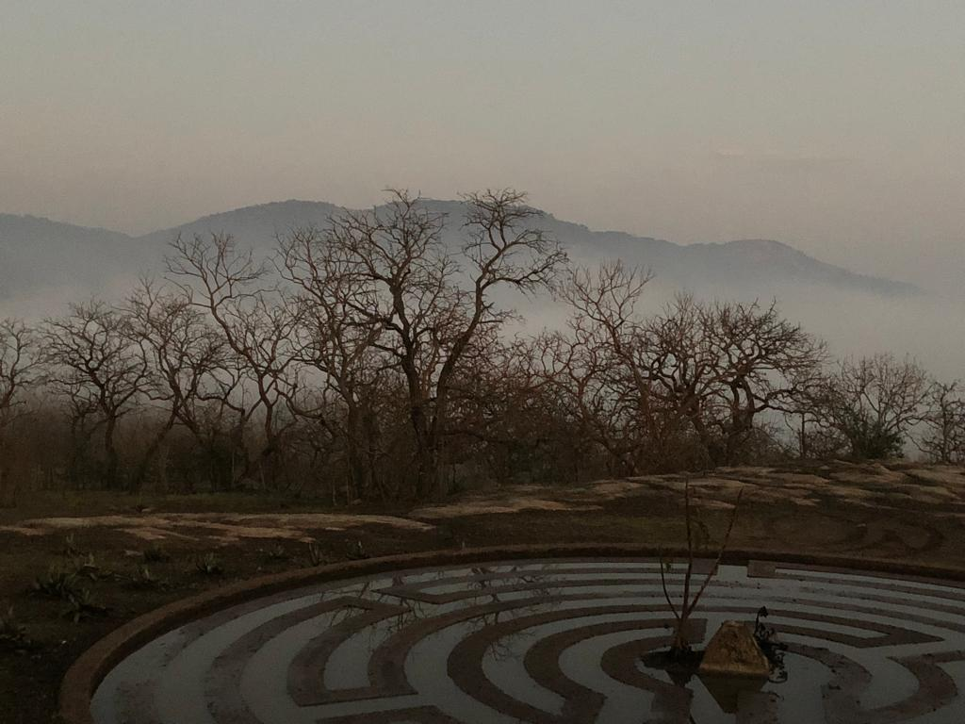
CAP INTERNATIONAL
Creativity & Innovation Programme
www.capinternational.art

SHAMAN

23 April – 6 May 2023

CAP INTERNATIONAL
Creativity & Innovation Programme
Included: A Creativity Workshop in Mpumalanga &
A Specialist Guided Visit to Art Galleries and Museums in Cape Town

Revitalise Your Creativity and Innovation Sense
Using the Tools of Thinking, Making, Narrative, Mindfulness, Experimentation and Learning

Our Programme

CAP International offers Creativity and Innovation Seminars that are unique in the world since they have a two-fold, bi-location structure, and comprise theory, history, practice, execution and exhibition. The first week of a Seminar entails a practical workshop on a game farm in Mpumalanga consisting of creativity and innovation tuition and development through thinking, experimentation, making and consolidation, as well as an elephant briefing and a visit to the Kruger National Park. Part of the experience here is a close-up engagement with wild nature and animals. During a workshop you only work with ephemeral natural materials, such as stone, wood and grass; you make their own paper and charcoal; you build hides and nests; and it all culminates in a Big Burn! The second week entails art theory and history talks on contemporary African art during an intense week of guided visits to contemporary art galleries, museums and colonial sites in Cape Town.

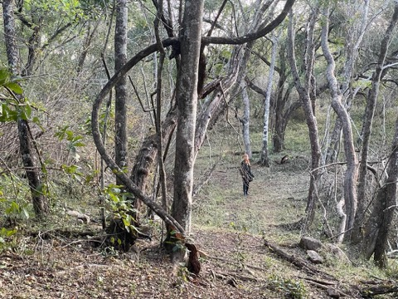
Aims and objectives

Our Creativity and Innovation Programme is aimed at problem solving, creating and critical thinking, generating with found, alternative, natural materials, but there is also a psychological, therapeutic and cathartic underpinning to the Seminars. Through the revitalisation of creative and innovative thinking, our Seminars seek to provide methodologies and processes that induce increased problem-solving skills and stimulate innovative approaches in the workplace or studio. The Programme is therefore suitable for people from different professions wishing to perform at their peak by enhancing, improving and activating their creativity. Concerned with both theory and practice, the Programme also considers connections between them. Therefore, we aim to stimulate imagination going back to raw nature and cultivate innovation skills through the implementation of imagination.

We empower individuals by developing creativity and innovation sensibility through a connection with raw African nature in protected environments and by providing academic tuition and creative practice under guidance of the best of South African expertise in the visual arts, creative thinking and veterinary science. We make use of the tools of thinking, making, storytelling, mindfulness, experimentation and learning under guidance of an Art Professor and the best available mentors, guides and scientists.
We are based in South Africa, but we work with clients worldwide. Our Seminars are conducted in English.
What is creativity?
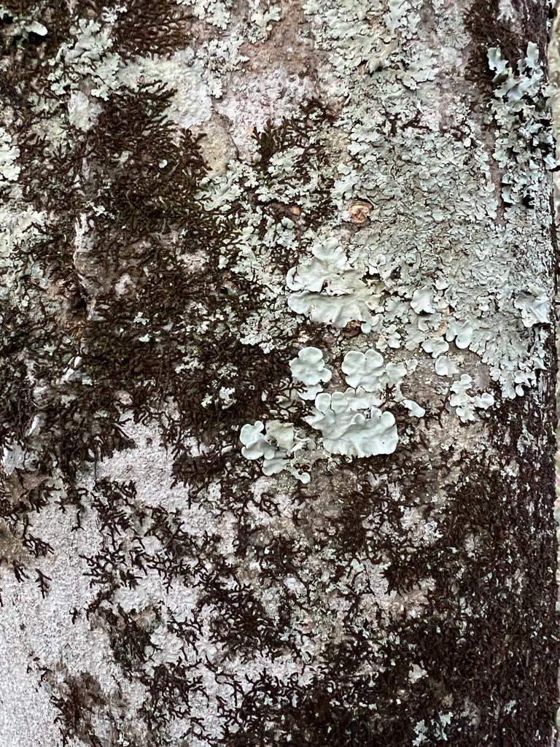
In the face of constantly increasing global and domestic competition, innovation and creativity have become essential components in the survival game. Creativity has long been a focus of scholarly research in many fields, including business and the sciences. What stimulates and prompts creativity, however, is a complex matter, even for art academics and specialists who have envisioned, taught and practised various methodologies over the years. What used to be a scholarly interest for a select few has become a compulsory matter for many.
According to scholars, it has to do with the recognition of possibilities; curiosity; fearlessness; flexibility; positivity; and motivation; amongst others. The good news: It can be taught, developed, and learnt! In Edward De Bono's Six Thinking Hats (1985) for instance, he identifies six distinct cognitive modes related to problem solving: the hats are black, blue, green, red, white, and yellow and they each represent frameworks and dispositions for thinking. The white hat is the information hat: wearing this the thinker considers facts at hand, laying a groundwork for creativity and innovation. The black hat represents scepticism and judgement, and the green hat represents possibility and newness. This is a useful methodology in teaching the steps in generating creative thinking.

Affinity mapping as a methodology known as the KJ Method or KJ Technique, is an idea generating and prioritising technique developed by ethnographer Jiro Kawakita; this methodology helps organise ideas, problems, solutions, and fragmented uncertain information into related groups after a brainstorming process.

These are but two of the available methodologies to assist in the development of creativity and innovation.

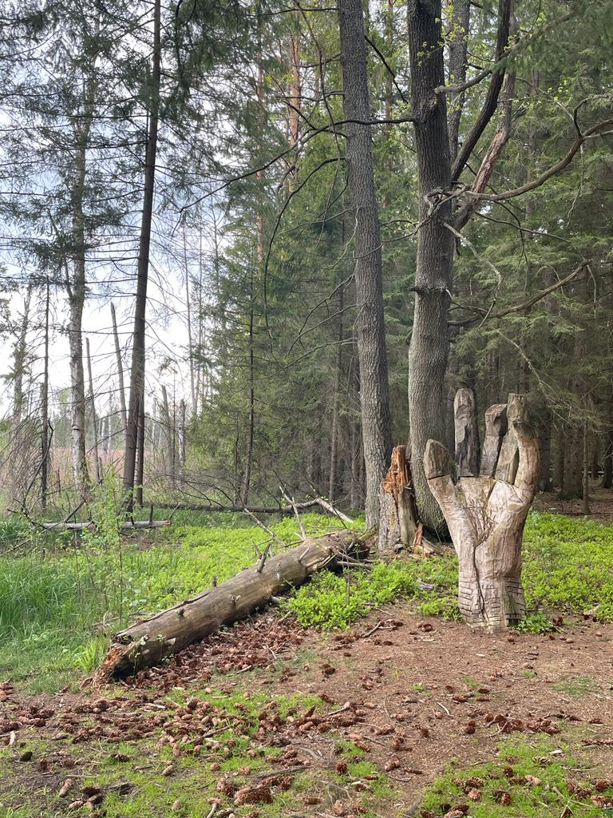
Experience authentic Africa – its landscape, materials, sounds, smells, myths, histories, people and art!

Upcoming Seminar:
Shaman
23 April- 6 May 2023
Why is shamanic practice becoming relevant again?

Psychogeological views of place and space are concerned with how our minds are shaped by our surroundings and the technologies we use. Living in postindustrial times – in which the machine (digital technology and media) has become God – has produced a sense of disconnection and alienation with many people. Similarly, covid has brought a condition of cocooning and withdrawal, as well as an intensification of online and virtual existence. In times of crisis, people look for solutions to transcend their current state of being. They try to find alternatives to transcend from what they are experiencing at that point in time. People are also worried about the future of planet earth; rumours of another world war; surging crime; and economic decline.
In the modern world, the artist has taken over the role of the shaman. The roles of the shaman and the artist have always been tied to vision and a position of being between two worlds: That of the visible and the invisible. Shamanism has roots outside of the West in the cultures of indigenous peoples across the world extending through Siberia, Australia, and Africa, as well as the Americas and pre-modern Europe. But shamanism itself is not a formalised system of beliefs or an ideology, but rather a philosophy and an outlook. Artists have always been engaged with making the invisible visible, and the artist as shaman is primarily aimed at healing, transformation and transcendence.
With the aim of remedying such as condition, our Programme offers revitalisation of creativity and innovation through an investigation of modern-day shamanism as a philosophy of life, a way of thinking and reconciliation with raw nature. Within the context of global competition and the continual emergence of new products, it has become critical for survival and success to be able to think creatively and innovatively. The Seminar offers an unforgettable experience in South Africa aimed at therapeutic self-discovery and takes place in safe, luxury environments. Creativity is rekindled in thinking and doing, and nurture problem solving skills are nurtured through the use of raw materials using primal natural artmaking processes and materials. It is suitable for anyone wishing to enhance their own creative thinking and problem-solving skills; for budding and professional artists; and for those wishing to reconnect with nature.
Our approach in the Creativity and Innovation Programme includes methodologies such as brainstorming; synectics; lateral thinking; morphological analysis; and inventive problem solving. Advanced experimental thinking will be cultivated and developed. Participants will be encouraged to move out of their comfort zone and to become shamanic in their thinking. There will be focus on each participant’s individual art production, techniques and thought processes. The Seminar also promotes collective consciousness and collectivity.
The Seminar mentor and Tour guide is Dr. Elfriede Dreyer, well-known arts academic, curator and artist with more than 30 years of experience in the South African arts industry. She leads the practical Seminar and act as tour guide in the Cape. She also provides discussion sessions on contemporary art; Ephemerality in artmaking; African Modernism; the South African arts industry; and more. Read more about her: www.elfriededreyer.com/bio
Keywords: Creative development | Psychogeograhy | Raw Nature | Healing |Transcendence |Transformation | Earth consciousness | Cosmogram | Bodygram | Masking | Collectivity | Recycling | Deconstruction | Journey

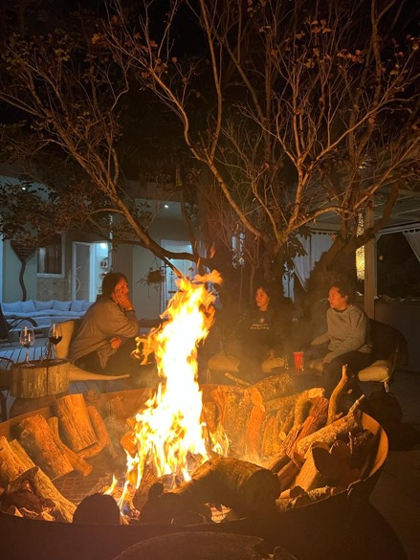
Locations

Ngongoni Farm Lodge, Mbombela, Mpumalanga

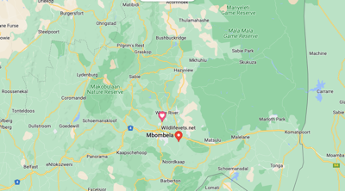

Yzerfontein, Western Cape
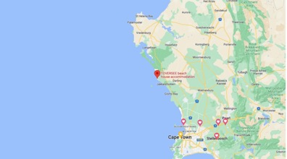

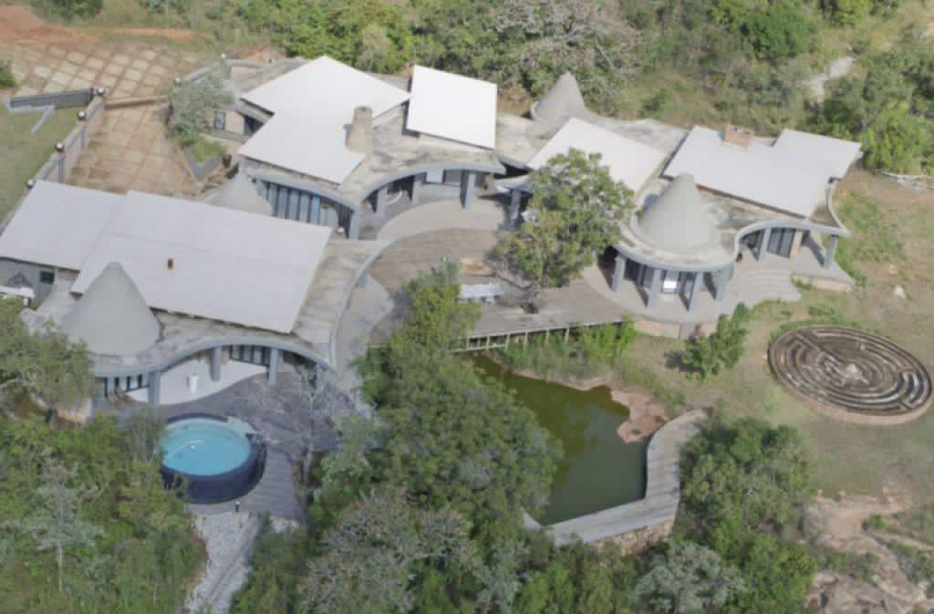
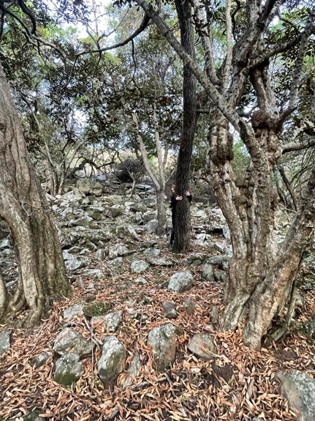
Itinerary

Day 1: Arrive Sunday, Mbombela (Kruger Mpumalanga International Airport, KMIA)
Starting Point Ngongoni Farm Lodge, Mbombela, You will be fetched from the airport. Most of the Seminar take place out in nature.
Evening Get to know each other around the fire; welcoming drinks and dinner at the boma; introduction to the Seminar. Make your own charcoal
Day 2: Monday – Masking & Figuration Narrative and Event. Spirit animal. Art/Life;. Taking stock of your Life. Transmutation
Day 3: Tuesday – Papermaking Make your own organic paper. Drawing with natural materials. Afternoon: Visit Khoi San cave drawings
Day 4: Wednesday – Mapping Walk the Labyrinth. Create your own trail. Map your personal journey
Day 5: Thursday – Ephemerality Collect ephemeral materials in the fairy forest and transform into a sculpture or installation (nests, hides, shrines, lanterns etc) in the forest. Elephant briefing by veterinary scientist: Participants are briefed on the state of Kruger’s elephant population and see for themselves what the importance is of management in a fenced ecosystem
Day 6: Friday – Artist Visit & The Burn Morning visit to a local artist. Afternoon: Building the Fire and Burn.
Day 7: Saturday - Kruger National Park Full Day Kruger Park Visit with guide, lunch.
Day 8: Sunday – Reflection, Flight to Cape Town Unpack the kiln. Reflection. Flight to Cape Town, settle in at accommodation close to V&A Waterfront, Cape Town. Sunset Cruise & dinner at V&A
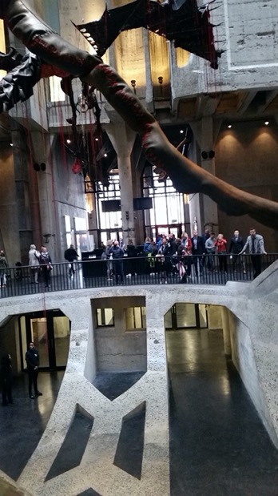
Day 10: Monday – The Norval Foundation & Groot Constantia Visit Norval Foundation (one the most important art institutions in SA) & Groot Constantia, an award-winning wine farm and a beacon in colonial South African history. Visit artist Lionel Smit in Somerset West. Evening: Discussion on the histories of South African art
Day 10: Tuesday – Zeitz MOCAA & V&A Waterfront Visit another cutting-edge art institution. Visit the Victoria & Albert Waterfront with its Silo District, the Harbour and Victoria Wharf. Market day. Optional: Tour to Robben Island where Nelson Mandela was incarcerated.
Day 11: Wednesday – Stellenbosch Visit art galleries in the picturesque university town; Tokara Wine Farm and Gallery; and Dylan Lewis Sculpture Garden, SMAC Gallery and others. Rupert Museum
Day 12: Thursday – Franschhoek Visit historical Franschhoek with its Huguenot Memorial Monument; many top-notch art galleries and shops. Galleries: Grande Provence, Everard Read, Tokara, Pierneff at La Motte. Afternoon departure for Yzerfontein, West Coast; visit to Khoi San Ikhwatu Cultural Centre
Day 13: Friday – West Coast Beach If weather permits, land art on the beach enjoying the beauty and splendour of the West Coast beach and ocean; otherwise discussions on Modernism and Postmodernism in Africa. Optional: Visit Melkbosstrand and surroundings
Day 14: Saturday – Return flights End Point Breakfast at Toversee and return flight.

Image: Zeitz MOCAA

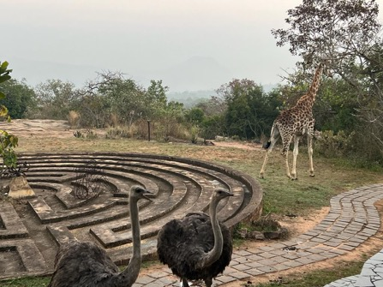
Cost

PRICE $3400 (EARLY BIRD, until 28 February 2023) $3500 (NORMAL PRICE)
DEPOSIT $2000 on booking to secure your spot
BALANCE 30 days before the commencement of your Seminar
DURATION 13 days
NUMBER OF PLACES PER EVENT 10
IDEAL PARTICIPANT Those seeking creative development, problemsolving skills and/or reconnection with nature; Professional and emerging artists; Art enthusiasts; Postgraduate Art students or students in their senior years
STARTS IN Mbombela, Mpumalanga ENDS IN Cape Town
OPERATOR CAP International . Art | CAP Institute for Contemporary Art Practice
TOUR CODE #20

What’s Included

Accommodation 7 nights in Mpumalanga on a game research farm owned by a veterinary scientist; and 6 nights in Cape Town including stays at the V&A Waterfront, Stellenbosch and Yzerfontein on the West Coast
Meals 3 meals per day at Ngongoni Lodge; 2 meals per day (breakfast + either lunch or dinner) in the Cape

Flights Only the flight from KMIA to Cape Town International Airport is included
Transport Transpost to and from venues is included
Guide & Mentor The Seminar and Art Tour guide is Dr. Elfriede Dreyer
Materials Art materials are included
Entry fees Entry fees to galleries and museums are included. Other Limited wine is included

Seminar Dates

STARTING IN Mbombela. ENDING IN. Cape Town

ALL DATES
23 April - 6 May 2023
25 June - 8 July 2023
16 - 29 July 2023
13 - 26 August 2023
3-16 September 2023
24 September - 7 October 2023
15 - 28 October 2023

More info: www.capinternational.art
Application form: www.capinternational.art/apply
Contact details: CAP Institute International | info@capinternational.art
Telephone Linda +27 82 928 2345 or Elfriede +27 83 271 2342

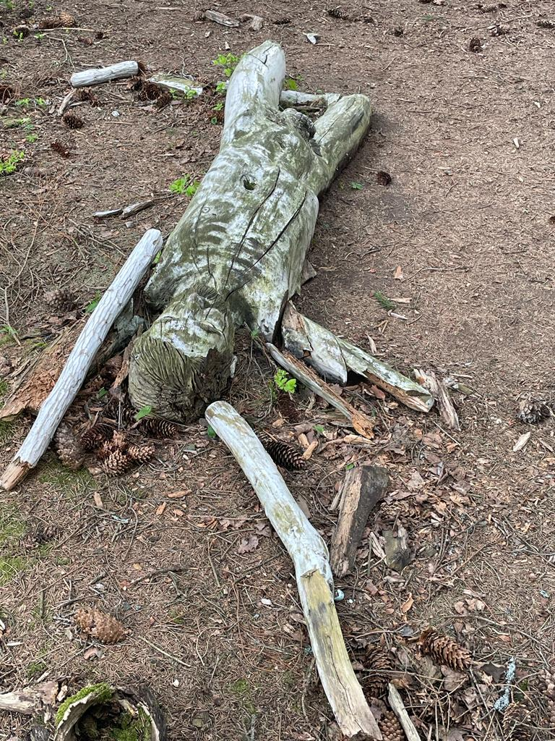
Terms & Conditions

Fees
- Once your application is approved you will need to pay the deposit ($2000.00 Euro) to secure your place. Banking details will be on your invoice. Deposits are non-refundable but are transferable to a future Seminar.
- Application turnaround time is about 3 days. If you have not heard from us, you are welcome to follow up via mail: info@capinternational.art
- Final outstanding balance to be paid 30 days before the starting date of your Seminar. Should you cancel your trip 30 days or less before arrival, the final payment is not refundable but is transferable to future Seminars.

Flights
- Flights are not included in the Seminar fees, but we can recommend a travel agent in South Africa to handle your bookings. Contact us if you want to make use of this.
- Fly from your country of origin to Johannesburg OR Oliver Tambo International Airport in South Africa, Johannesburg. Take a connecting flight to Kruger Mpumalanga International Airport (KMIA) – quickest option after a long flight. Airport website.
- Should you need to stay over in Johannesburg, please stay close to the airport and use a Shuttle service provided by the hotel. Be aware of whom you use for transport in order to travel efficiently and safely. City Lodge Hotel at O.R. International Airport. We advise you to handle your own luggage, be firm and say no to other services.
- Provide us your arrival times so that we can fetch you from KMIA.
- Please travel lightly with cabin luggage only as we don’t have space in our bus for large pieces of luggage. We do your laundry before we go to Cape Town.
- We have a high rate of petty crime, so please look after your valuables all times. Always keep an eye on your bags, don’t leave anything laying around and keep cash, phones, cameras on your person, not in plain view.
- We provide internet at the accommodation.

General
- We prepare vegetarian food with meat on the side.
- You’ll be arriving in our autumn or winter season. Days are warm but evenings and mornings can be very cold. We suggest that you plan to dress in layers and bring a warm jacket/coat.
- You’ll be staying at Ngongoni Lodge. We are located on a specialist game farm in a rural area. Due to busy Seminar schedules, limited vehicles and our location, we can’t just ‘nip into town’. We do NOT recommend/nor accommodate visits to bars/clubs in the evenings. All evening activities are based on the farm.
- We advise that you pay a visit to their doctor and get a broad-spectrum antibiotic for just in case. Also get a pro-biotic for your tummy.
- We do not require any vaccinations for your visit but check with your doctor as to what your home country requirements are for re-entry. For more info regarding COVID and South Africa please follow this link: https://sacoronavirus.co.za
- The lodge is not located in a Malaria area. You will be entering areas with malaria, but a good mosquito repellent is the best defense. We do not take Malaria medication ourselves. For more info please visit this site. Be aware of the medication you take – it is not always necessary, and the side effects may prevent you from having the best experience on the Seminar.

South Africa
- Please Note: You will be attending the Seminar in South Africa, a country in Africa, and NOT Southern Africa which refers to a region of the continent of Africa. South Africa is a well-developed country, with very good infrastructure. This also means that we are not affected by most of the issues you might encounter on the media regarding Africa. There are no wild animals running around in our streets. Wild animals are encountered in wildlife areas/parks/farms/sanctuaries, and on our farm in fenced areas.
- Our currency is Rand (ZAR). Check out the latest exchange rate here. Most stores accept Mastercard and Visa. There are ATMs everywhere.
- We have 11 official languages in South Africa. Swahili is not one of them.
- During the Seminar you are in our care, and we make every effort to ensure your safety and wellbeing. Please do not arrange private trips with friends or other operators during the Seminar. No one is permitted to leave the group during the Seminar with any person that does NOT work for us.

Your Stay
- We provide shared, good accommodation at the Ngongoni Lodge and in the Cape.
- If we have time in the afternoons, we will take you up onto one of the hilltops on the farm, for a sundowner in the bush.
- Bring enough clothes for 7 days – we will then take your clothes to a laundromat to be washed.
- We have credit card facilities at the Lodge. We accept only Mastercard and Visa.

